Practical 1

Er- diagram Using ERD plus:

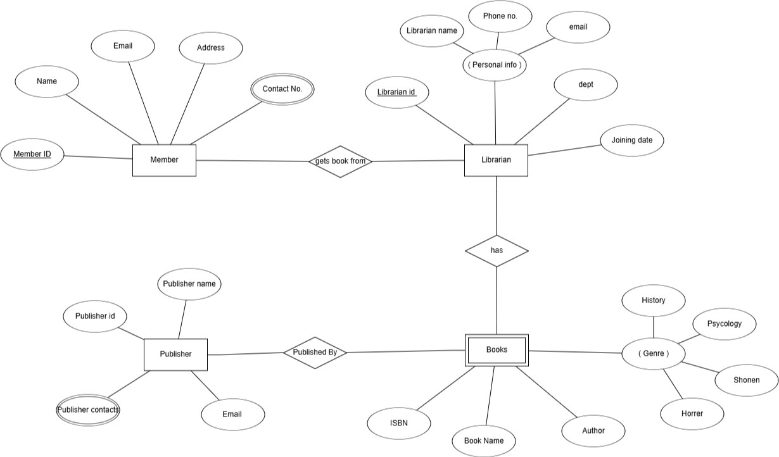

Library Management System ER diagram

Practical 2 (A)

mysql> show databases;
+ +
| Database |
+ +
| employee_db |
| information_schema |
| mysql |
| performance_schema |
| studentdb |
| sys |
+ +
6 rows in set (0.00 sec)

mysql> USE studentdb;
Database changed
mysql> CREATE TABLE Student( Stuid INT PRIMARY KEY, Name VARCHAR(100) NOT NULL, Gender CHAR(1) CHECK(Gender IN ('M', 'F')), DOB DATE, Dept VARCHAR(50));
Query OK, 0 rows affected (0.05 sec)

mysql> CREATE TABLE Enrollment (Enrollid INT PRIMARY KEY, Stuid INT, Subject VARCHAR(50), Grade CHAR(2), FOREIGN KEY( Stuid) REFERENCES Student(Stuid));
Query OK, 0 rows affected (0.05 sec)

mysql> INSERT INTO Student (Stuid, Name, Gender, DOB, Dept) VALUES(1, ' Adnan Bagwan', 'M', '2003-04-12', 'Computer Science'), (2, 'Priya Sharma', 'F', '2002-09-23', 'Information
Technology'), (3, 'Rahul Deshmukh', 'M', '2001-07-18', 'Electronics'), (4, 'Sneha Patil', 'F', '2003-
02-02', 'Mechanical'), (5, 'Aman Verma', 'M', '2002-12-30', 'Civil'); Query OK, 5 rows affected (0.01 sec)
Records: 5 Duplicates: 0 Warnings: 0

mysql> INSERT INTO Enrollment (Enrollid, Stuid, Subject, Grade) VALUES (101, 1, 'Database Systems', 'A'), (102, 2, 'Operating Systems', 'B+'), (103, 3, 'Data Structures', 'A'), (104, 4, 'Computer Networks', 'B'), (105, 5, 'Software Engineering', 'A+');
Query OK, 5 rows affected (0.01 sec) Records: 5 Duplicates: 0 Warnings: 0

mysql> SELECT * FROM Student;
+ + + + + +
| Stuid | Name | Gender | DOB | Dept |
+ + + + + +
| 1 | Adnan Bagwan | M | 2003-04-12 | Computer Science |
| 2 | Priya Sharma | F | 2002-09-23 | Information Technology |
| 3 | Rahul Deshmukh | M | 2001-07-18 | Electronics |
| 4 | Sneha Patil | F | 2003-02-02 | Mechanical |
| 5 | Aman Verma | M | 2002-12-30 | Civil |
+ + + + + +
5 rows in set (0.00 sec)

mysql> SELECT * FROM Enrollment;
+ + + + +
| Enrollid | Stuid | Subject | Grade |
+ + + + +
| 101 | 1 | Database Systems | A |
| 102 | 2 | Operating Systems | B+ |
| 103 | 3 | Data Structures | A |
| 104 | 4 | Computer Networks | B |
| 105 | 5 | Software Engineering | A+ |
+ + + + +
5 rows in set (0.00 sec)

mysql> CREATE VIEW Highscore AS SELECT s.Stuid, s.Name, s.Dept, e.Subject, e.Grade FROM Student s JOIN Enrollment e ON s.Stuid = e.Stuid WHERE e.Grade IN ('A', 'A+');
Query OK, 0 rows affected (0.01 sec)

mysql> SELECT * FROM Highscore;
+ + + + + +
| Stuid | Name | Dept | Subject | Grade |
+ + + + + +
| 1 | Adnan Bagwan | Computer Science | Database Systems | A |
| 3 | Rahul Deshmukh | Electronics | Data Structures | A |
| 5 | Aman Verma | Civil | Software Engineering | A+ |
+ + + + + +
3 rows in set (0.00 sec)

mysql> CREATE INDEX idxstuname ON Student(Name); Query OK, 0 rows affected (0.07 sec)
Records: 0 Duplicates: 0 Warnings: 0

mysql> SELECT * FROM Student WHERE Name = 'Priya Sharma';
+ + + + + +
| Stuid | Name | Gender | DOB | Dept |
+ + + + + +
| 2 | Priya Sharma | F | 2002-09-23 | Information Technology |
+ + + + + +
1 row in set (0.00 sec)

Practical-2(B)
mysql> create database stu;
Query OK, 1 row affected (0.00 sec)

mysql> use stu;
Database changed
mysql> CREATE TABLE students (student_id INT NOT NULL AUTO_INCREMENT PRIMARY KEY,
first_name VARCHAR(50) NOT NULL, last_name VARCHAR(50), email VARCHAR(100) UNIQUE, age INT CHECK (age >= 17), dept_id INT) ENGINE=InnoDB DEFAULT CHARSET=utf8mb4;
Query OK, 0 rows affected (0.04 sec)

mysql> CREATE TABLE departments (dept_id INT NOT NULL AUTO_INCREMENT PRIMARY KEY, dept_name VARCHAR(100) NOT NULL UNIQUE) ENGINE=InnoDB DEFAULT CHARSET=utf8mb4;
Query OK, 0 rows affected (0.03 sec)

mysql> select *from students; Empty set (0.00 sec)

mysql> select *from deparments;
ERROR 1146 (42S02): Table 'stu.deparments' doesn't exist mysql> select *from departments;
Empty set (0.00 sec)

mysql> INSERT INTO departments (dept_name) VALUES ('Computer Science'), ('Mechanical'), ('Electrical');
Query OK, 3 rows affected (0.01 sec) Records: 3 Duplicates: 0 Warnings: 0

mysql> select *from departments;
+ + +
| dept_id | dept_name |
+ + +
| 1 | Computer Science |
| 3 | Electrical |
| 2 | Mechanical |
+ + +
3 rows in set (0.00 sec)

mysql> INSERT INTO students (first_name, last_name, email, age, dept_id) VALUES ('Adnan',
'Bagwan', 'aniket@gmail.com', 20, 1), ('Sneha', 'Sharma', 'sneha@gmail.com', 19, 2), ('Amit', 'Kumar',
'amit@gmail.com', 21, 1), ('Priya', 'Desai', 'priya@gmail.com', 18, 3); Query OK, 4 rows affected (0.01 sec)
Records: 4 Duplicates: 0 Warnings: 0

mysql> select *from students;
+ + + + + + +
| student_id | first_name | last_name | email | age | dept_id |

+ + + + + + +
| 1 | Adnan | Bagwan | aniket@gmail.com | 20 | 1 |
| 2 | Sneha | Sharma | sneha@gmail.com | 19 | 2 |
| 3 | Amit | Kumar | amit@gmail.com | 21 | 1 |
| 4 | Priya | Desai | priya@gmail.com | 18 | 3 |
+ + + + + + +
4 rows in set (0.00 sec)

mysql> SELECT s.first_name, s.last_name, d.dept_name FROM students s JOIN departments d ON s.dept_id = d.dept_id;
+ + + +
| first_name | last_name | dept_name |
+ + + +
| Adnan | Bagwan | Computer Science |
| Sneha | Sharma | Mechanical |
| Amit | Kumar | Computer Science |
| Priya | Desai | Electrical |
+ + + +
4 rows in set (0.00 sec)

mysql> SELECT first_name, age FROM students WHERE age > 19;
+ + +
| first_name | age |
+ + +
| Adnan | 20 |
| Amit | 21 |
+ + +
2 rows in set (0.00 sec)

mysql> SELECT d.dept_name, COUNT(*) AS total_students FROM students s JOIN departments d ON s.dept_id = d.dept_id GROUP BY d.dept_name;
+ + +
| dept_name | total_students |
+ + +
| Computer Science | 2 |
| Electrical | 1 |
| Mechanical | 1 |
+ + +
3 rows in set (0.00 sec)

mysql> SELECT first_name, age FROM students ORDER BY age ASC;
+ + +
| first_name | age |
+ + +
| Priya | 18 |
| Sneha | 19 |
| Adnan | 20 |
| Amit | 21 |

+ + +
4 rows in set (0.00 sec)

mysql> SELECT UPPER(CONCAT(first_name, ' ', last_name)) AS full_name FROM students;
+ +
| full_name |
+ +
| ADNAN BAGWAN|
| SNEHA SHARMA |
| AMIT KUMAR |
| PRIYA DESAI |
+ +
4 rows in set (0.00 sec)

mysql> CREATE VIEW student_view AS SELECT s.student_id, s.first_name, s.last_name, d.dept_name, s.email FROM students s JOIN departments d ON s.dept_id = d.dept_id;
Query OK, 0 rows affected (0.01 sec)

mysql> SELECT * FROM student_view;
+ + + + + +
| student_id | first_name | last_name | dept_name | email |
+ + + + + +
| 1 | Adnan | Bagwan | Computer Science | aniket@gmail.com |
| 2 | Sneha | Sharma | Mechanical | sneha@gmail.com |
| 3 | Amit | Kumar | Computer Science | amit@gmail.com |
| 4 | Priya | Desai | Electrical | priya@gmail.com |
+ + + + + +
4 rows in set (0.00 sec)

mysql> UPDATE students SET email = 'rohan123@gmail.com' WHERE first_name = 'Rohan'; Query OK, 0 rows affected (0.00 sec)
Rows matched: 0 Changed: 0 Warnings: 0

mysql> DELETE FROM students WHERE first_name = 'Amit'; Query OK, 1 row affected (0.01 sec)

mysql> SELECT student_id, first_name, dept_id FROM students;
+ + + +
| student_id | first_name | dept_id |
+ + + +
| 1 | Adnan | 1 |
| 2 | Sneha | 2 |
| 4 | Priya | 3 |
+ + + +
3 rows in set (0.00 sec)

Practical-3

mysql> create database s;
Query OK, 1 row affected (0.00 sec)
mysql> use s;
Database changed

mysql> CREATE TABLE departments (dept_id INT AUTO_INCREMENT PRIMARY KEY, dept_name VARCHAR(100) NOT NULL);
Query OK, 0 rows affected (0.01 sec)

mysql> CREATE TABLE students (student_id INT AUTO_INCREMENT PRIMARY KEY, first_name
VARCHAR(50), last_name VARCHAR(50), age INT, dept_id INT, FOREIGN KEY (dept_id) REFERENCES departments(dept_id));
Query OK, 0 rows affected (0.04 sec)
mysql> CREATE TABLE courses (course_id INT AUTO_INCREMENT PRIMARY KEY, course_name VARCHAR(100), dept_id INT, FOREIGN KEY (dept_id) REFERENCES departments(dept_id));
Query OK, 0 rows affected (0.04 sec)

mysql> INSERT INTO departments (dept_name) VALUES ('Computer Science'), ('Mechanical'), ('Electrical');
Query OK, 3 rows affected (0.01 sec)
Records: 3 Duplicates: 0 Warnings: 0
mysql> INSERT INTO students (first_name, last_name, age, dept_id) VALUES ('Adnan', 'Bagwan', 20, 1), ('Sneha', 'Sharma', 19, 2), ('Amit', 'Kumar', 21, 1), ('Priya', 'Desai', 18, 3), ('Vikas', 'Singh', 22, 1); Query OK, 5 rows affected (0.01 sec)
Records: 5 Duplicates: 0 Warnings: 0

mysql> INSERT INTO courses (course_name, dept_id) VALUES ('Database Systems', 1), ('Data Structures', 1), ('Thermodynamics', 2), ('Circuit Analysis', 3), ('Operating Systems', 1);
Query OK, 5 rows affected (0.01 sec)
Records: 5 Duplicates: 0 Warnings: 0
mysql> SELECT s.first_name, s.last_name, d.dept_name FROM students s INNER JOIN departments d ON s.dept_id = d.dept_id;
+ + + +
| first_name | last_name | dept_name |
+ + + +
| Adnan | Bagwan | Computer Science |
| Sneha | Sharma | Mechanical |
| Amit | Kumar | Computer Science |
| Priya | Desai | Electrical |
| Vikas | Singh | Computer Science |
+ + + +
5 rows in set (0.00 sec)

mysql> SELECT s.first_name, d.dept_name FROM students s LEFT JOIN departments d ON
s.dept_id = d.dept_id;

+ + +
| first_name | dept_name |
+ + +
| Adnan | Computer Science |
| Sneha | Mechanical |
| Amit | Computer Science |
| Priya | Electrical |
| Vikas | Computer Science |
+ + +
5 rows in set (0.00 sec)

mysql> SELECT d.dept_name, s.first_name FROM students s RIGHT JOIN departments d ON s.dept_id
= d.dept_id;
+ + +
| dept_name | first_name |
+ + +
| Computer Science | Adnan |
| Mechanical | Sneha |
| Computer Science | Amit |
| Electrical | Priya |
| Computer Science | Vikas |
+ + +
5 rows in set (0.00 sec)
mysql> SELECT a.first_name AS Student1, b.first_name AS Student2, a.dept_id FROM students a JOIN students b ON a.dept_id = b.dept_id WHERE a.student_id < b.student_id;
+ + + +
| Student1 | Student2 | dept_id |
+ + + +
| Adnan | Amit | 1 |
| Adnan | Vikas | 1 |
| Amit | Vikas | 1 |
+ + + +
3 rows in set (0.00 sec)
mysql> SELECT first_name, age FROM students WHERE age = (SELECT MAX(age) FROM students s JOIN departments d ON s.dept_id = d.dept_id WHERE d.dept_name = 'Computer Science');
+ + +
| first_name | age |
+ + +
| Vikas | 22 |
+ + +
1 row in set (0.00 sec)
mysql> CREATE VIEW student_details AS SELECT s.student_id, s.first_name, s.last_name, s.age, d.dept_name FROM students s JOIN departments d ON s.dept_id = d.dept_id;
Query OK, 0 rows affected (0.01 sec)

mysql> SELECT * FROM student_details;

+ + + + + +
| student_id | first_name | last_name | age | dept_name |
+ + + + + +
| 1 | Adnan | Bagwan | 20 | Computer Science |
| 2 | Sneha | Sharma | 19 | Mechanical |
| 3 | Amit | Kumar | 21 | Computer Science |
| 4 | Priya | Desai | 18 | Electrical |
| 5 | Vikas | Singh | 22 | Computer Science |
+ + + + + +
5 rows in set (0.00 sec)

Practical-4

mysql> USE library;
Reading table information for completion of table and column names You can turn off this feature to get a quicker startup with -A
Database changed mysql> DELIMITER //
mysql> CALL B1(1, 'TOC') //
+ +
| NOT FOUND |
+ +
| NOT FOUND |
+ +
1 row in set (0.35 sec)
Query OK, 0 rows affected (0.41 sec) mysql> SELECT * FROM Borrower; //
+ + + + + +
| roll_no | name | DOI | book_name | status |
+ + + + + +
| 12 | Adnan Bagwan | 2025-07-01 | xyz | issued |
| 14 | Sneha Sharma | 2025-06-01 | oop | issued |
| 16 | Amit Kumar | 2025-05-01 | coa | returned |
| 18 | Priya Desai | 2025-06-15 | toc | returned |
| 20 | Vikas Singh | 2025-05-15 | mp | issued |
+ + + + + +
5 rows in set (0.00 sec)

mysql> SHOW TABLES; //
+ +
| Tables_in_library |
+ +
| Borrower |
| Employee |
| customer |
| orders |
| person |
| product_master |
| state |
+ +
13 rows in set (0.00 sec)

mysql> CREATE PROCEDURE B(roll_new INT, book_name VARCHAR(20))
-> BEGIN
-> DECLARE X INTEGER;

-> DECLARE CONTINUE HANDLER FOR NOT FOUND
-> BEGIN
-> SELECT 'NOT FOUND';
-> END;
->
-> SELECT DATEDIFF(CURDATE(), DOI) INTO X
-> FROM Borrower
-> WHERE roll_no = roll_new;
->
-> IF (X > 15 AND X < 30) THEN
-> INSERT INTO Fine VALUES (roll_new, CURDATE(), (X * 5));
-> END IF;
->
-> IF (X > 30) THEN
-> INSERT INTO Fine VALUES (roll_new, CURDATE(), (X * 50));
-> END IF;
->
-> UPDATE Borrower
-> SET status = 'returned'
-> WHERE roll_no = roll_new;
-> END;
-> //
Query OK, 0 rows affected (0.02 sec)

mysql> CALL B(12, 'xyz'); //
Query OK, 1 row affected (0.42 sec)

mysql> SELECT * FROM Fine; //
+ + + +
| roll_no | fine_date | amount |
+ + + +
| 12 | 2025-07-28 | 135 |
+ + + +
1 row in set (0.00 sec)

mysql> SELECT * FROM Borrower; //
+ + + + + +
| roll_no | name | DOI | book_name | status |
+ + + + + +
| 12 | Adnan Bagwan | 2025-07-01 | xyz | returned |
| 14 | Sneha Sharma | 2025-06-01 | oop | issued |
| 16 | Amit Kumar | 2025-05-01 | coa | returned |
| 18 | Priya Desai | 2025-06-15 | toc | returned |
| 20 | Vikas Singh | 2025-05-15 | mp | issued |
+ + + + + +
5 rows in set (0.00 sec)

mysql> CALL B(20, 'Vikas Singh'); //

Query OK, 1 row affected (0.35 sec)

mysql> SELECT * FROM Fine; //

+ + + +
| roll_no | fine_date | amount |
+ + + +
| 12 | 2025-07-28 | 135 |
| 20 | 2025-07-28 | 3700 |
+ + + +
2 rows in set (0.00 sec)

mysql> SELECT * FROM Borrower; //
+ + + + + +
| roll_no | name | DOI | book_name | status |
+ + + + + +
| 12 | Adnan Bagwan | 2025-07-01 | xyz | returned |
| 14 | Sneha Sharma | 2025-06-01 | oop | issued |
| 16 | Amit Kumar | 2025-05-01 | coa | returned |
| 18 | Priya Desai | 2025-06-15 | toc | returned |
| 20 | Vikas Singh | 2025-05-15 | mp | returned |
+ + + + + +
5 rows in set (0.00 sec)

Practical-5

mysql> create table marks(roll_no int,name varchar(20),total_marks varchar(20)); Query OK, 0 rows affected (0.67 sec)
mysql> create table result(roll_no int,name varchar(20),class varchar(20)); Query OK, 0 rows affected (0.41 sec)
mysql> insert into marks values('1','Adnan','1400'); Query OK, 1 row affected (0.04 sec)
mysql> insert into marks values('2','Sneha','980'); Query OK, 1 row affected (0.08 sec)
mysql> insert into marks values('3','Amit','880'); Query OK, 1 row affected (0.08 sec)
mysql> insert into marks values('4','Priya','820'); Query OK, 1 row affected (0.08 sec)
mysql> insert into marks values('5','Vikas','740'); Query OK, 1 row affected (0.03 sec)
mysql> insert into marks values('6','Aniket','640'); Query OK, 1 row affected (0.08 sec)
mysql> delimiter //

mysql> create procedure proc_result(in marks int,out class char(20))
-> begin
-> if(marks<1500&&marks>990)
-> then
-> set class='Distincton';
-> end if;
-> if(marks<989&&marks>890)
-> then
-> set class='First Class';
-> end if;

-> if(marks<889&&marks>825)
-> then
-> set class='Higher Second Class';
-> end if;
-> if(marks<824&&marks>750)
-> then
-> set class='Second Class';-> end if;if(marks<749&&marks>650)
-> then
-> set class='Passed';
-> end if;
-> if(marks<649)
-> then
-> set class='Fail';
-> end if;
-> end;
-> //
Query OK, 0 rows affected (0.00 sec)

mysql> create function final_result3(R1 int)
-> returns int
-> begin
-> declare fmarks integer;
-> declare grade varchar(20);
-> declare stud_name varchar(20);
-> select marks.total_marks,marks.name into
fmarks,stud_name from marks where marks.roll_no=R1;
-> call proc_grade(fmarks,@grade);
-> insert into result values(R1,stud_name,@grade);
-> return R1;
-> end;
-> //
Query OK, 0 rows affected (0.00 sec) mysql> select final_result3(2);
-> //
+ +
| final_result3(2) |
+ +
|2 |
+ +
1 row in set (0.05 sec)

mysql> select final_result3(3);//
+ +
| final_result3(3) |
+ +

|3 |
+ +
1 row in set (0.04 sec)

mysql> select final_result3(4);//
+ +
| final_result3(4) |
+ +
|4 |

1 row in set (0.12 sec)

mysql> select final_result3(5);//

+ +
| final_result3(5) |
+ +
|5 |
+ +
1 row in set (0.05 sec)
mysql> select * from result;

-> //
+ + + +
| roll_no | name | class |
+ + + +
| 1 | NULL | Distincton |
| 1 | Adnan| Distincton |
| 1 | Adnan| Distincton |
| 2 | Sneha | First Class |
| 3 | Amit | Higher Second Class|
| 4 | Priya | Second Class |
| 5 | Vikas | Passed |
+ + + +
7 rows in set (0.00 sec)

Practical- 6
mysql> create table o_rollcall(roll_no int,name varchar(20),address varchar(20)); Query OK, 0 rows affected (0.28 sec)

mysql> create table n_rollcall(roll_no int,name varchar(20),address varchar(20)); Query OK, 0 rows affected (0.27 sec)

mysql> insert into o_rollcall values('1','Adnan','Pune'); Query OK, 1 row affected (0.05 sec)

mysql> insert into o_rollcall values('2','Sneha','MP'); Query OK, 1 row affected (0.06 sec)

mysql> insert into o_rollcall values('3','Amit','Nsk'); Query OK, 1 row affected (0.05 sec)

mysql> insert into o_rollcall values('4','Priya','Dhule'); Query OK, 1 row affected (0.05 sec)

mysql> insert into o_rollcall values('5','Vikas','Satara'); Query OK, 1 row affected (0.04 sec)

mysql> delimiter //

mysql> create procedure p3(in r1 int)
-> begin
-> declare r2 int;
-> declare exit_loop boolean;
-> declare c1 cursor for select roll_no from o_rollcall where roll_no>r1;
-> declare continue handler for not found set exit_loop=true;
-> open c1;
-> e_loop:loop
-> fetch c1 into r2;
-> if not exists(select * from n_rollcall where roll_no=r2)
-> then
-> insert into n_rollcall select * from o_rollcall where roll_no=r2;
-> end if;
-> if exit_loop
-> then
-> close c1;
-> leave e_loop;
-> end if;
-> end loop e_loop;
-> end;
-> //
Query OK, 0 rows affected (0.00 sec)

mysql> call p3(3);
-> //
Query OK, 0 rows affected (0.10 sec)

mysql> select * from n_rollcall;
-> //
+ + + +
| roll_no | name | address |
+ + + +
| 4 | Priya | Dhule |
| 5 | Vikas | Satara |
+ + + +
2 rows in set (0.00 sec)

mysql> call p3(0);
-> //
Query OK, 0 rows affected (0.22 sec)

mysql> select * from n_rollcall;
-> //
+ + + +
| roll_no | name | address |
+ + + +
| 4 | Priya | Dhule |
| 5 | Vikas | Satara |
| 1 | Adnan | Pune |
| 2 | Sneha | MP |
| 3 | Amit | Nsk |
+ + + +
5 rows in set (0.00 sec)

mysql> insert into o_rollcall values('6','Sanket','Kolhapur');
-> //
Query OK, 1 row affected (0.04 sec)

mysql> call p3(4);
-> //
Query OK, 0 rows affected (0.05 sec)
mysql> select * from n_rollcall;
-> //
+ + + +
| roll_no | name | address |
+ + + +
| 4 | Priya | Dhule |
| 5 | Vikas | Satara |
| 1 | Adnan | Pune |
| 2 | Sneha | MP |

| 3 | Amit | Nsk |
| 6 | Sanket | Kolhapur |
+ + + +
6 rows in set (0.00 sec)

Practical-7

mysql> create table borrower (rollin int, name varchar(30), dateofissue date, nameofbook varchar(30), status char(10));
Query OK, 0 rows affected (0.05 sec)

mysql> insert borrower values
-> (101, 'Adnan', '2025-07-16', 'dbms', 'r'),
-> (102, 'Sneha', '2025-07-16', 'cn', 'i'),
-> (103, 'Amit', '2025-07-18', 'toc', 'i'),
-> (104, 'Priya', '2025-07-20', 'ds', 'i'),
-> (105, 'Vikas', '2025-07-23', 'daa', 'r'),
-> (106, 'Nisha', '2025-08-10', 'splm', 'r');
Query OK, 6 rows affected (0.01 sec) Records: 6 Duplicates: 0 Warnings: 0

mysql> create table library_audit(
-> rollin int,
-> name char(10),
-> dateofissue date,
-> nameofbook char(10),
-> status char,
-> ts timestamp
-> );
Query OK, 0 rows affected (0.04 sec) mysql> delimiter //
mysql> create trigger after_insert
-> after insert on borrower
-> for each row
-> begin
-> insert into library_audit values(new.rollin, new.name, new.dateofissue,
-> new.nameofbook, new.status, current_timestamp);
-> end;
-> //
Query OK, 0 rows affected (0.08 sec)

mysql> select * from borrower //
+ + + + + +
| rollin | name | dateofissue | nameofbook | status |

+ | + + + + | +
| | 101 | Adnan | 2025-07-16 | dbms | | r |
| | 102 | Sneha | 2025-07-16 | cn | | i | |
| | 103 | Amit | 2025-07-18 | toc | | i | |
| | 104 | Priya | 2025-07-20 | ds | | i | |
| | 105 | Vikas | 2025-07-23 | daa | | r | |

| 106 | Nisha | 2025-08-10 | splm | r |
+ + + + + +
6 rows in set (0.00 sec)

mysql> select * from library_audit // Empty set (0.00 sec)

mysql> insert into borrower values(107, 'Sanket', '2025-08-10', 'dbms', 'i') // Query OK, 1 row affected (0.02 sec)

mysql> select * from borrower //
+ + + + + +
| rollin | name | dateofissue | nameofbook | status |
+ + + + + +
| 101 | Adnan | 2025-07-16 | dbms | r |
| 102 | Sneha | 2025-07-16 | cn | i |
| 103 | Amit | 2025-07-18 | toc | i |
| 104 | Priya | 2025-07-20 | ds | i |
| 105 | Vikas | 2025-07-23 | daa | r |
| 106 | Nisha | 2025-08-10 | splm | r |
| 107 | Sanket | 2025-08-10 | dbms | i |
+ + + + + +
7 rows in set (0.00 sec)

mysql> select * from library_audit //
+ + + + + + +
| rollin | name | dateofissue | nameofbook | status | ts |
+ + + + + + +
| 107 | Sanket | 2025-08-10 | dbms | i | 2025-10-27 05:24:57 |
+ + + + + + +
1 row in set (0.00 sec)

mysql> create trigger after_delete
-> after delete on borrower
-> for each row
-> begin
-> insert into library_audit values(old.rollin, old.name, old.dateofissue,
-> old.nameofbook, old.status, current_timestamp());
-> end;
-> //
Query OK, 0 rows affected (0.08 sec)

mysql> delete from borrower where rollin = 105 // Query OK, 1 row affected (0.02 sec)

mysql> select * from borrower //
+ + + + + +
| rollin | name | dateofissue | nameofbook | status |

+ + + + + +
| 101 | Adnan| 2025-07-16 | dbms | r |
| 102 | Sneha | 2025-07-16 | cn | i |
| 103 | Amit | 2025-07-18 | toc | i |
| 104 | Priya | 2025-07-20 | ds | i |
| 106 | Nisha | 2025-08-10 | splm | r |
| 107 | Sanket | 2025-08-10 | dbms | i |
+ + + + + +
6 rows in set (0.00 sec)

mysql> select * from library_audit //
+ + + + + + +
| rollin | name | dateofissue | nameofbook | status | ts |
+ + + + + + +
| 107 | Sanket | 2025-08-10 | dbms | i | 2025-10-27 05:24:57 |
| 105 | Vikas | 2025-07-23 | daa | r | 2025-10-27 05:26:51 |
+ + + + + + +
2 rows in set (0.00 sec)

mysql> create trigger after_update
-> after update on borrower
-> for each row
-> begin
-> insert into library_audit values(new.rollin, new.name, new.dateofissue,
-> new.nameofbook, new.status, current_timestamp());
-> end;
-> //
Query OK, 0 rows affected (0.08 sec)

mysql> update borrower set status='r' where borrower.rollin=104 // Query OK, 1 row affected (0.04 sec)
Rows matched: 1 Changed: 1 Warnings: 0

mysql> select * from borrower //
+ + + + + +
| rollin | name | dateofissue | nameofbook | status |
+ + + + + +
| 101 | Adnan | 2025-07-16 | dbms | r |
| 102 | Sneha | 2025-07-16 | cn | i |
| 103 | Amit | 2025-07-18 | toc | i |
| 104 | Priya | 2025-07-20 | ds | r |
| 106 | Nisha | 2025-08-10 | splm | r |
| 107 | Sanket | 2025-08-10 | dbms | i |
+ + + + + +
6 rows in set (0.00 sec)

mysql> select * from library_audit //

+ + + + + + +

| rollin | name | dateofissue | nameofbook | status | ts |
+ + + + + + +
| 107 | Sanket | 2025-08-10 | dbms | i | 2025-10-27 05:24:57 |
| 105 | Vikas | 2025-07-23 | daa | r | 2025-10-27 05:26:51 |
| 104 | Priya | 2025-07-20 | ds | r | 2025-10-27 05:28:10 |
+ + + + + + +
3 rows in set (0.00 sec)

Practical-8
Frontend:
<!DOCTYPE html>
<html lang="en">
<head>
<meta charset="UTF-8">
<meta name="viewport" content="width=device-width, initial-scale=1.0">
<title>Student Management System - MySQL</title>
<link rel="stylesheet" href="styles.css">
</head>
<body>
<div class="container">
<header>
<h1>Student Management System</h1>
<p class="subtitle">MySQL Database Connectivity</p>
</header>

<div class="main-content">
<!-- Student Form -->
<div class="form-section">
<h2 id="form-title">‘) ¸• Add New Student</h2>
<form id="studentForm">
<input type="hidden" id="studentId">
<div class="form-group">
<label for="name">Name:</label>
<input type="text" id="name" required placeholder="Enter student name">
</div>
<div class="form-group">
<label for="age">Age:</label>
<input type="number" id="age" required min="16" max="30" placeholder="Enter

age">

</div>
<div class="form-group">
<label for="email">Email:</label>
<input type="email" id="email" required placeholder="Enter email address">
</div>
<div class="form-group">
<label for="course">Course:</label>
<input type="text" id="course" required placeholder="Enter course name">
</div>
<div class="form-group">
<label for="grade">Grade:</label>
<select id="grade" required>
<option value="">Select Grade</option>
<option value="A">A - Excellent</option>
<option value="B">B - Good</option>

<option value="C">C - Average</option>
<option value="D">D - Below Average</option>
<option value="F">F - Fail</option>
</select>
</div>
<div class="form-buttons">
<button type="submit" id="submitBtn">+ Add Student</button>
<button type="button" id="cancelBtn" style="display: none;">+ Cancel</button>
</div>
</form>
</div>

<!-- Search Section -->
<div class="search-section">
<input type="text" id="searchInput" placeholder="•˙Q Search students by name, email, or course...">
<button onclick="searchStudents()">Search</button>
<button onclick="loadStudents()">Show All</button>
<button onclick="checkHealth()">Health Check</button>
</div>

<!-- Students Table -->
<div class="table-section">
<h2>/¡ #ç Student Records</h2>
<div id="loading" class="loading">,‡¯’_ Loading students...</div>
<div id="error" class="error" style="display: none;"></div>

<table id="studentsTable">
<thead>
<tr>
<th>ID</th>
<th>Name</th>
<th>Age</th>
<th>Email</th>
<th>Course</th>
<th>Grade</th>
<th>Actions</th>
</tr>
</thead>
<tbody id="studentsTableBody">
</tbody>
</table>

<div id="noData" class="no-data" style="display: none;">
¡ '← No students found. Add some students to get started!
</div>
</div>

</div>
</div>

<script src="script.js"></script>
</body>
</html>

Database.sql file:
-- Create database
CREATE DATABASE IF NOT EXISTS studentdb;
USE studentdb;

-- Create students table
CREATE TABLE IF NOT EXISTS students (
id INT AUTO_INCREMENT PRIMARY KEY, name VARCHAR(100) NOT NULL,
age INT NOT NULL,
email VARCHAR(100) UNIQUE NOT NULL, course VARCHAR(100) NOT NULL,
grade VARCHAR(2) NOT NULL,
created_at TIMESTAMP DEFAULT CURRENT_TIMESTAMP,
updated_at TIMESTAMP DEFAULT CURRENT_TIMESTAMP ON UPDATE CURRENT_TIMESTAMP
);

-- Insert sample data
INSERT INTO students (name, age, email, course, grade) VALUES
('Aniket Kamble', 20, 'aniket@gmail.com', 'Computer Science', 'A'), ('Sanket Patil', 22, 'sanket@gmail.com', 'Mathematics', 'B'),
('Nishant Mane', 21, 'nishant@gmail.com', 'Physics', 'A'),
('Adnan Bagwan', 19, 'adnan@gmail.com', 'Chemistry', 'B');

Server.js:
const express = require('express');
const mysql = require('mysql2/promise'); const cors = require('cors');
const bodyParser = require('body-parser'); require('dotenv').config();

const app = express();
const PORT = process.env.SERVER_PORT || 5000;

// Middleware app.use(cors()); app.use(bodyParser.json());
app.use(express.static('public'));

// MySQL Connection Pool for XAMPP const createPool = () => {

return mysql.createPool({
host: process.env.DB_HOST || 'localhost', user: process.env.DB_USER || 'root',
password: process.env.DB_PASSWORD || '', // Empty for XAMPP database: process.env.DB_NAME || 'studentdb',
port: process.env.DB_PORT || 3306, waitForConnections: true, connectionLimit: 10,
queueLimit: 0
});
};

let pool = createPool();

// Test database connection
const testConnection = async () => { try {
const connection = await pool.getConnection();
console.log('⬛ Connected to MySQL database successfully!'); console.log('#ç ¡/ Using XAMPP MySQL server');
connection.release();
} catch (error) {
console.error('+ Database connection failed:', error.message); console.log('.•9„˙ Make sure XAMPP MySQL is running on port 3306');
}
};

testConnection();

// Routes (same as previous server.js, but I'll include the essential parts)

// GET all students
app.get('/api/students', async (req, res) => { try {
const [rows] = await pool.execute('SELECT * FROM students ORDER BY created_at DESC'); res.json(rows);
} catch (error) {
console.error('Error fetching students:', error);
res.status(500).json({ message: 'Error fetching students', error: error.message });
}
});

// POST create new student app.post('/api/students', async (req, res) => {
try {
const { name, age, email, course, grade } = req.body;

if (!name || !age || !email || !course || !grade) {
return res.status(400).json({ message: 'All fields are required' });
}

const [result] = await pool.execute(
'INSERT INTO students (name, age, email, course, grade) VALUES (?, ?, ?, ?, ?)', [name, age, email, course, grade]
);

const [newStudent] = await pool.execute('SELECT * FROM students WHERE id = ?', [result.insertId]);
res.status(201).json(newStudent[0]);
} catch (error) {
console.error('Error creating student:', error); if (error.code === 'ER_DUP_ENTRY') {
res.status(400).json({ message: 'Email already exists' });
} else {
res.status(500).json({ message: 'Error creating student', error: error.message });
}
}
});

// PUT update student app.put('/api/students/:id', async (req, res) => {
try {
const { name, age, email, course, grade } = req.body; const studentId = req.params.id;

if (!name || !age || !email || !course || !grade) {
return res.status(400).json({ message: 'All fields are required' });
}

const [result] = await pool.execute(
'UPDATE students SET name = ?, age = ?, email = ?, course = ?, grade = ? WHERE id = ?', [name, age, email, course, grade, studentId]
);

if (result.affectedRows === 0) {
return res.status(404).json({ message: 'Student not found' });
}

const [updatedStudent] = await pool.execute('SELECT * FROM students WHERE id = ?', [studentId]);
res.json(updatedStudent[0]);
} catch (error) {
console.error('Error updating student:', error); if (error.code === 'ER_DUP_ENTRY') {
res.status(400).json({ message: 'Email already exists' });

} else {
res.status(500).json({ message: 'Error updating student', error: error.message });
}
}
});

// DELETE student
app.delete('/api/students/:id', async (req, res) => { try {
const [result] = await pool.execute('DELETE FROM students WHERE id = ?', [req.params.id]);

if (result.affectedRows === 0) {
return res.status(404).json({ message: 'Student not found' });
}

res.json({ message: 'Student deleted successfully' });
} catch (error) {
console.error('Error deleting student:', error);
res.status(500).json({ message: 'Error deleting student', error: error.message });
}
});

// Search students
app.get('/api/students/search/:query', async (req, res) => { try {
const query = `%${req.params.query}%`; const [rows] = await pool.execute(
'SELECT * FROM students WHERE name LIKE ? OR email LIKE ? OR course LIKE ? ORDER BY created_at DESC',
[query, query, query]
);
res.json(rows);
} catch (error) {
console.error('Error searching students:', error);
res.status(500).json({ message: 'Error searching students', error: error.message });
}
});

// Health check
app.get('/api/health', async (req, res) => { try {
await pool.execute('SELECT 1');
res.json({ status: 'OK', database: 'Connected', server: 'XAMPP MySQL' });
} catch (error) {
res.status(500).json({ status: 'Error', database: 'Disconnected', error: error.message });
}
});

app.listen(PORT, () => {
console.log(`s7'¸•.˙ Server is running on port ${PORT}`); console.log(`#/¡ ç Database: ${process.env.DB_NAME}`); console.log(` ³ Frontend: http://localhost:${PORT}`); console.log(` ³ phpMyAdmin: http://localhost/phpmyadmin`);
});

Output:

Frontend:
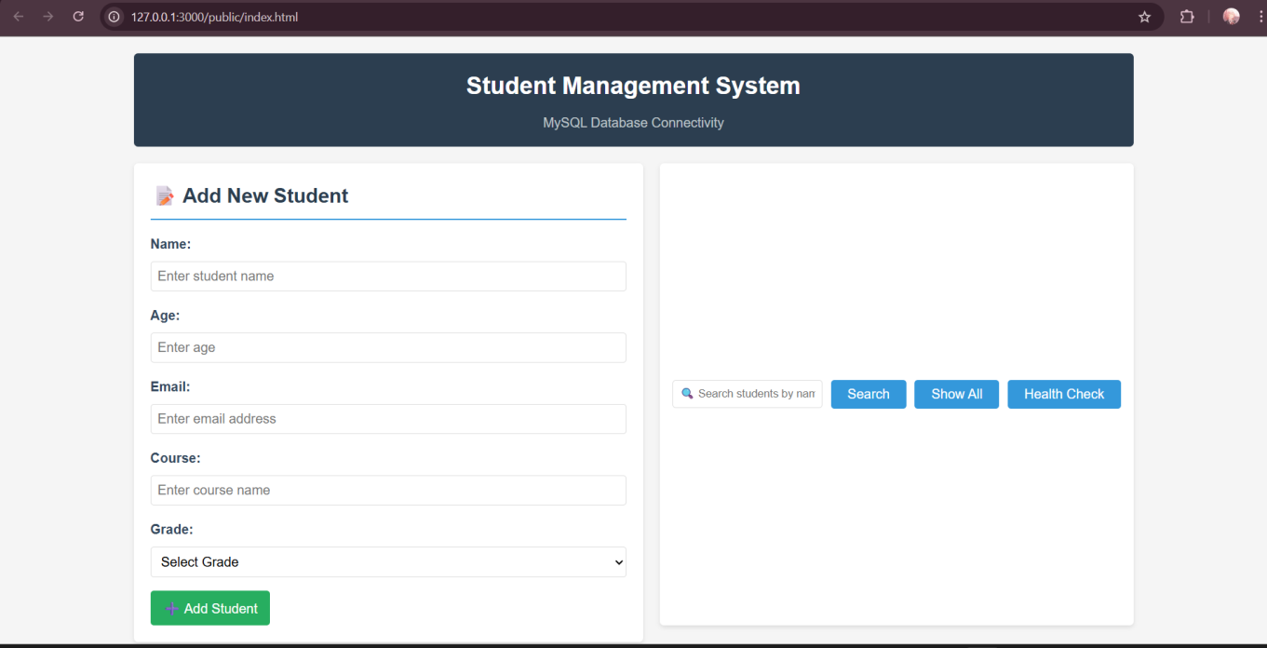
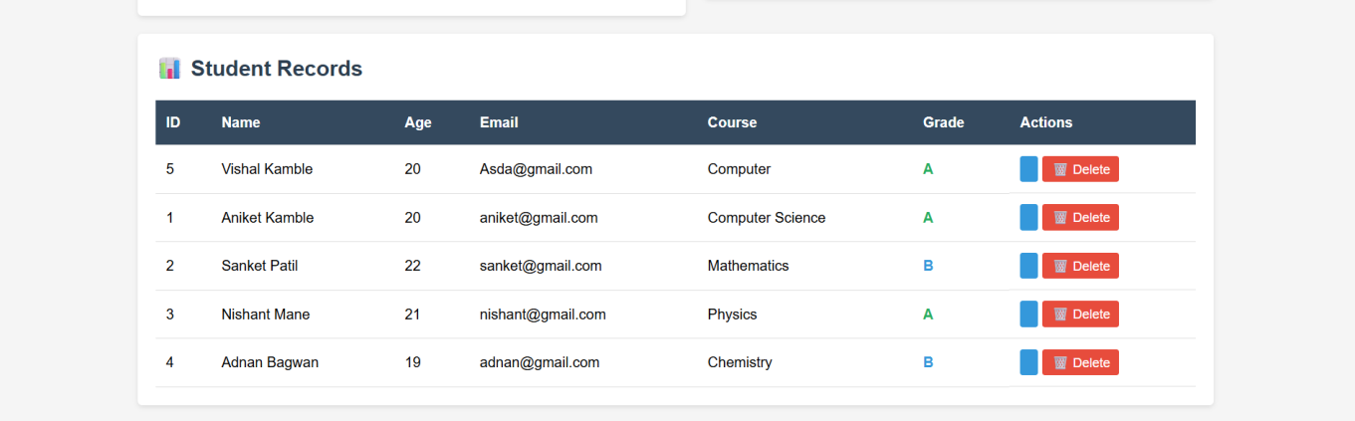

CRUD operations:

Add:
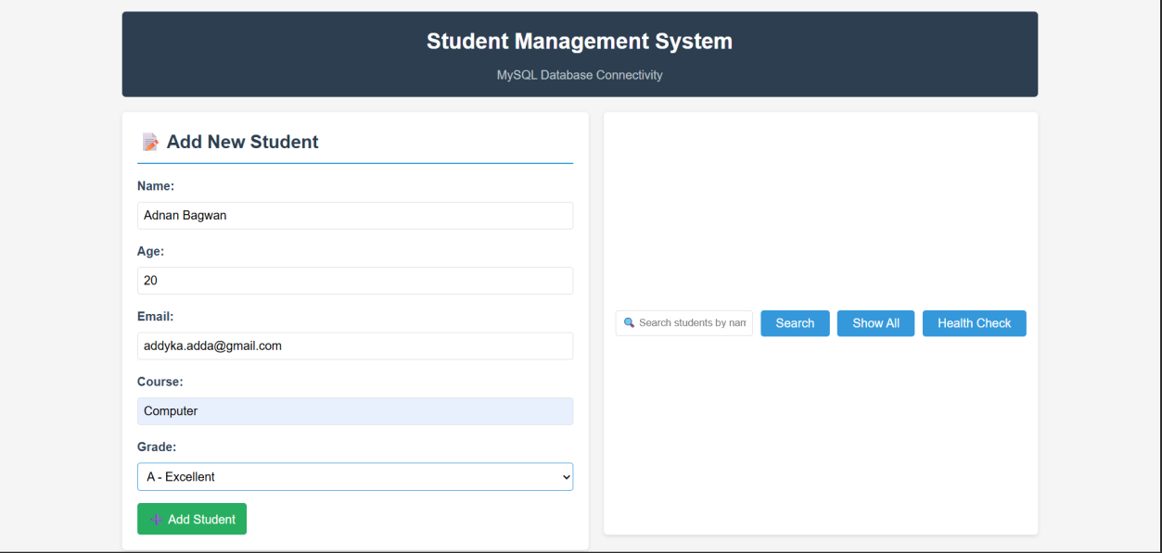

Delete:
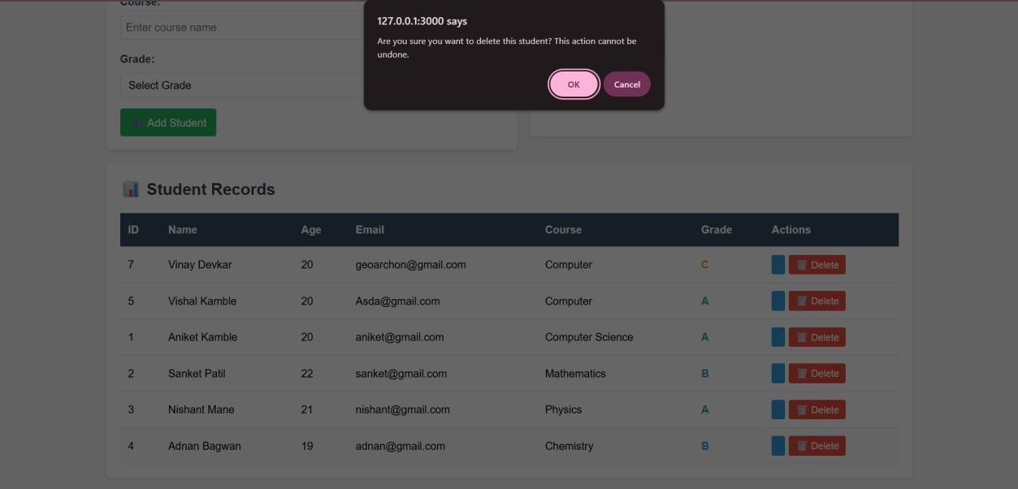
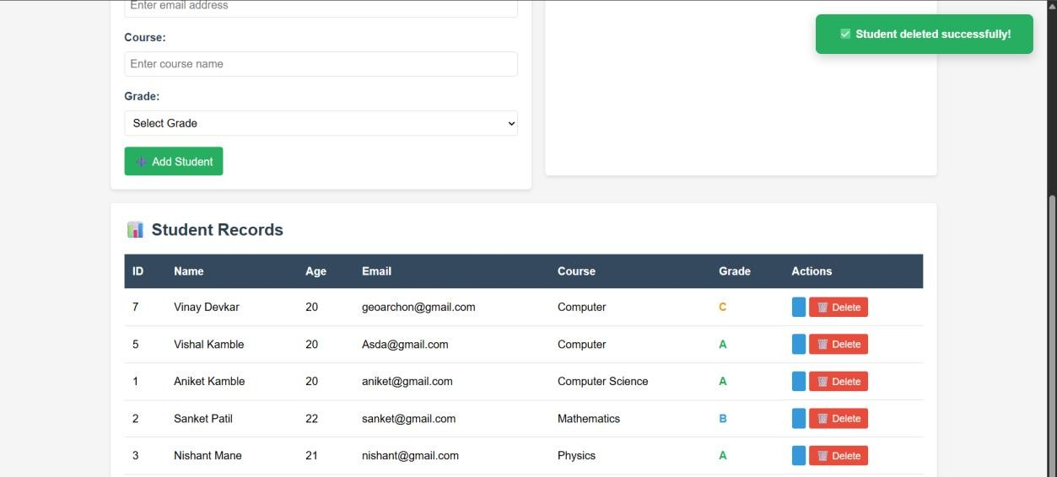

Search:
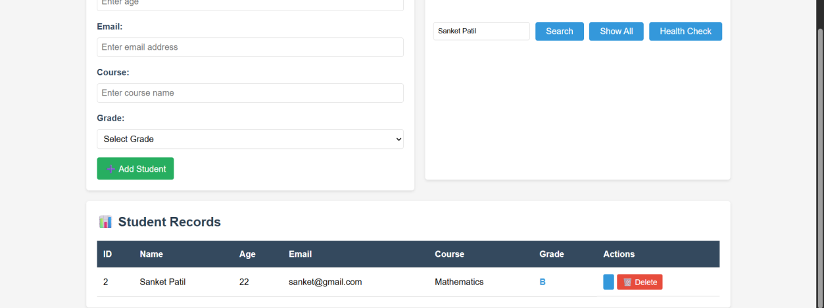

Updated/show:
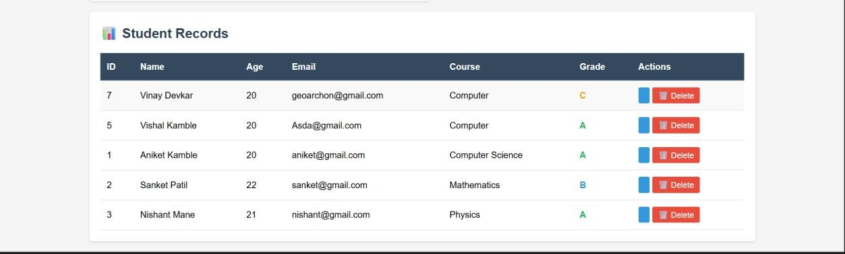

Database coneectivity in cmd;
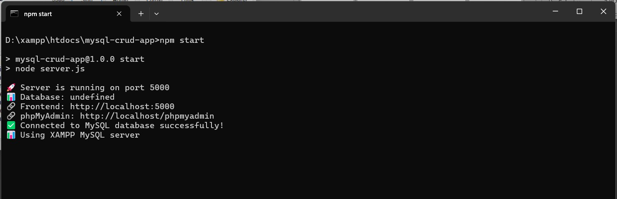

Practical-9

Current Mongosh Log ID: 68ffc62e28a8b26e7bcebea3 Connecting to:
mongodb://127.0.0.1:27017/?directConnection=true&serverSelectionTimeoutMS=2000&appName= mongosh+2.5.8
Using MongoDB: 8.2.1
Using Mongosh: 2.5.8
For mongosh info see: https://www.mongodb.com/docs/mongodb-shell/ test> show dbs;
admin 40.00 KiB
config 36.00 KiB
local 72.00 KiB
seed 76.00 KiB
student 40.00 KiB test> use collegeDB;
switched to db collegeDB
collegeDB> db.students.insertOne({
... name: "Adnan Bagwan",
... age: 20,
... course: "Information Technology",
... year: 2,
... marks: 76,
... city: "Nagpur"
... })
...
{
acknowledged: true,
insertedId: ObjectId('68ffc7f928a8b26e7bcebea4')
}
collegeDB> db.students.insertMany([
... {
... name: "Sanket Patil",
... age: 21,
... course: "Computer Engineering",
... year: 3,
... marks: 85,
... city: "Pune"
... },
... {
... name: "Sneha Sharma",
... age: 20,
... course: "Mechanical",
... year: 2,
... marks: 72,

... city: "Mumbai"
... },
... {
... name: "Rohan Patil",
... age: 22,
... course: "Electrical",
... year: 4,
... marks: 65,
... city: "Nashik"
... },
... {
... name: "Priya Desai",
... age: 19,
... course: "Computer Engineering",
... year: 1,
... marks: 90,
... city: "Pune"
... }
... ])
...
{
acknowledged: true, insertedIds: {
'0': ObjectId('68ffc84f28a8b26e7bcebea5'),
'1': ObjectId('68ffc84f28a8b26e7bcebea6'),
'2': ObjectId('68ffc84f28a8b26e7bcebea7'),
'3': ObjectId('68ffc84f28a8b26e7bcebea8')
}
}
collegeDB> db.students.find(); [
{
_id: ObjectId('68ffc7f928a8b26e7bcebea4'), name: 'Adnan Bagwan',
age: 20,
course: 'Information Technology', year: 2,
marks: 76,
city: 'Nagpur'
},
{
_id: ObjectId('68ffc84f28a8b26e7bcebea5'), name: 'Sanket Patil',
age: 21,
course: 'Computer Engineering', year: 3,
marks: 85, city: 'Pune'

},
{
_id: ObjectId('68ffc84f28a8b26e7bcebea6'), name: 'Sneha Sharma',
age: 20,
course: 'Mechanical', year: 2,
marks: 72,
city: 'Mumbai'
},
{
_id: ObjectId('68ffc84f28a8b26e7bcebea7'), name: 'Rohan Patil',
age: 22,
course: 'Electrical', year: 4,
marks: 65,
city: 'Nashik'
},
{
_id: ObjectId('68ffc84f28a8b26e7bcebea8'), name: 'Priya Desai',
age: 19,
course: 'Computer Engineering', year: 1,
marks: 90, city: 'Pune'
}
]
collegeDB> db.students.find({ name: "Adnan Bagwan" }); [
{
_id: ObjectId('68ffc7f928a8b26e7bcebea4'), name: 'Adnan Bagwan',
age: 20,
course: 'Information Technology', year: 2,
marks: 76,
city: 'Nagpur'
}
]
collegeDB> db.students.find({ city: "Pune" }); [
{
_id: ObjectId('68ffc84f28a8b26e7bcebea5'), name: 'Sanket Patil',
age: 21,
course: 'Computer Engineering',

year: 3,
marks: 85, city: 'Pune'
},
{
_id: ObjectId('68ffc84f28a8b26e7bcebea8'), name: 'Priya Desai',
age: 19,
course: 'Computer Engineering', year: 1,
marks: 90, city: 'Pune'
}
]
collegeDB> db.students.updateOne(
... { name: "Adnan Bagwan" },
... { $set: { marks: 88 } }
... )
...
{
acknowledged: true, insertedId: null, matchedCount: 1,
modifiedCount: 1,
upsertedCount: 0
}
collegeDB> db.students.updateMany(
... { course: "Computer Engineering" },
... { $inc: { marks: 2 } }
... )
...
{
acknowledged: true, insertedId: null, matchedCount: 2,
modifiedCount: 2,
upsertedCount: 0
}

collegeDB> db.students.deleteMany({ marks: { $lt: 70 } });
{ acknowledged: true, deletedCount: 1 } collegeDB> db.students.find({
... $or: [
... { city: "Pune" },
... { marks: { $gt: 80 } }
... ]
... })
...

[
{
_id: ObjectId('68ffc7f928a8b26e7bcebea4'),

name: 'Adnan Bagwan',

age: 20,
course: 'Information Technology', year: 2,
marks: 88,
city: 'Nagpur'
},
{
_id: ObjectId('68ffc84f28a8b26e7bcebea5'), name: 'Sanket Patil',
age: 21,
course: 'Computer Engineering', year: 3,
marks: 87, city: 'Pune'
},
{
_id: ObjectId('68ffc84f28a8b26e7bcebea8'), name: 'Priya Desai',
age: 19,
course: 'Computer Engineering', year: 1,
marks: 92, city: 'Pune'
}
]
collegeDB> db.students.find({}, { _id: 0, name: 1, marks: 1 }).sort({ marks: -1 }) [
{ name: 'Priya Desai', marks: 92 },
{ name: 'Adnan Bagwan', marks: 88 },
{ name: 'Sanket Patil', marks: 87 },
{ name: 'Sneha Sharma', marks: 72 }
]
collegeDB>

Practical-10

Current Mongosh Log ID: 68ffcbbbde5aae794bcebea3

test> use collegeDB;
switched to db collegeDB
collegeDB> db.students.insertMany([
... { roll: 1, name: "Adnan Bagwan", course: "Computer Engineering", marks: 88, city: "Mumbai", year: "TE" },
... { roll: 2, name: "Riya Patel", course: "Information Technology", marks: 90, city: "Pune", year: "BE" },
... { roll: 3, name: "Amit Sharma", course: "Computer Engineering", marks: 75, city: "Nagpur", year: "SE" },
... { roll: 4, name: "Sneha Deshmukh", course: "AI & DS", marks: 82, city: "Mumbai", year: "BE" },
... { roll: 5, name: "Rohan Joshi", course: "IT", marks: 68, city: "Nashik", year: "FE" },
... { roll: 6, name: "Priya Mehta", course: "Computer Engineering", marks: 95, city: "Pune", year: "BE" }
... ]);
...
{
acknowledged: true, insertedIds: {
'0': ObjectId('68ffcbd6de5aae794bcebea4'),
'1': ObjectId('68ffcbd6de5aae794bcebea5'),
'2': ObjectId('68ffcbd6de5aae794bcebea6'),
'3': ObjectId('68ffcbd6de5aae794bcebea7'),
'4': ObjectId('68ffcbd6de5aae794bcebea8'),
'5': ObjectId('68ffcbd6de5aae794bcebea9')
}
}
collegeDB> db.students.aggregate([
... { $group: { _id: "$course", avgMarks: { $avg: "$marks" } } }
... ]);
... [
{ _id: 'IT', avgMarks: 68 },
{ _id: 'Information Technology', avgMarks: 90 },
{ _id: 'Computer Engineering', avgMarks: 86 },
{ _id: 'AI & DS', avgMarks: 82 }
]
collegeDB> db.students.aggregate([
... { $match: { city: "Mumbai" } },
... { $group: { _id: "$city", avgMarks: { $avg: "$marks" }, count: { $sum: 1 } } }
... ]);
...
[ { _id: 'Mumbai', avgMarks: 85, count: 2 } ] collegeDB> db.students.aggregate([
... { $sort: { marks: -1 } }

... ]);
... [
{
_id: ObjectId('68ffcbd6de5aae794bcebea9'), roll: 6,
name: 'Priya Mehta',
course: 'Computer Engineering', marks: 95,
city: 'Pune',
year: 'BE'
},
{
_id: ObjectId('68ffcbd6de5aae794bcebea5'), roll: 2,
name: 'Riya Patel',
course: 'Information Technology', marks: 90,
city: 'Pune',
year: 'BE'
},
{
_id: ObjectId('68ffcbd6de5aae794bcebea4'), roll: 1,
name: 'Adnan Bagwan',
course: 'Computer Engineering', marks: 88,
city: 'Mumbai', year: 'TE'
},
{
_id: ObjectId('68ffcbd6de5aae794bcebea7'), roll: 4,
name: 'Sneha Deshmukh', course: 'AI & DS',
marks: 82,
city: 'Mumbai', year: 'BE'
},
{
_id: ObjectId('68ffcbd6de5aae794bcebea6'), roll: 3,
name: 'Amit Sharma',
course: 'Computer Engineering', marks: 75,
city: 'Nagpur', year: 'SE'
},

{
_id: ObjectId('68ffcbd6de5aae794bcebea8'), roll: 5,

name: 'Rohan Joshi', course: 'IT',

marks: 68,
city: 'Nashik', year: 'FE'
}
]
collegeDB> db.students.aggregate([
... { $project: { _id: 0, name: 1, marks: 1 } }
... ]);
... [
{ name: 'Adnan Bagwan', marks: 88 },
{ name: 'Riya Patel', marks: 90 },
{ name: 'Amit Sharma', marks: 75 },
{ name: 'Sneha Deshmukh', marks: 82 },
{ name: 'Rohan Joshi', marks: 68 },
{ name: 'Priya Mehta', marks: 95 }
]
collegeDB> db.students.aggregate([
... { $group: { _id: "$city", totalStudents: { $sum: 1 } } },
... { $sort: { totalStudents: -1 } }
... ]);
... [
{ _id: 'Pune', totalStudents: 2 },
{ _id: 'Mumbai', totalStudents: 2 },
{ _id: 'Nashik', totalStudents: 1 },
{ _id: 'Nagpur', totalStudents: 1 }
]
collegeDB> db.students.createIndex({ marks: 1 }); marks_1
collegeDB> db.students.createIndex({ course: 1, city: 1 }); course_1_city_1
collegeDB> db.students.getIndexes(); [
{ v: 2, key: { _id: 1 }, name: '_id_' },
{ v: 2, key: { marks: 1 }, name: 'marks_1' },
{ v: 2, key: { course: 1, city: 1 }, name: 'course_1_city_1' }
]
collegeDB>

Practical-11

Current Mongosh Log ID: 68ffcd2c20201519fdcebea3 Connecting to:
mongodb://127.0.0.1:27017/?directConnection=true&serverSelectionTimeoutMS=2000&appName= mongosh+2.5.8
Using MongoDB: 8.2.1
Using Mongosh: 2.5.8
For mongosh info see: https://www.mongodb.com/docs/mongodb-shell/
The server generated these startup warnings when booting
2025-10-23T11:59:30.250+05:30: Access control is not enabled for the database. Read and write access to data and configuration is unrestricted

test> show dbs admin 40.00 KiB
collegeDB 88.00 KiB
config 108.00 KiB
local 72.00 KiB
seed 76.00 KiB
student 40.00 KiB test> use collegeDB;
switched to db collegeDB
collegeDB> db.students.deleteMany({})
{ acknowledged: true, deletedCount: 6 } collegeDB> db.results.insertMany([
... { name: "Adnan Bagwan", subject: "Math", marks: 85 },
... { name: "Adnan Bagwan", subject: "Science", marks: 90 },
... { name: "Riya Patel", subject: "Math", marks: 95 },
... { name: "Riya Patel", subject: "Science", marks: 88 },
... { name: "Amit Sharma", subject: "Math", marks: 70 },
... { name: "Amit Sharma", subject: "Science", marks: 75 }
... ]);
...
{
acknowledged: true, insertedIds: {
'0': ObjectId('68ffce1020201519fdcebea4'),
'1': ObjectId('68ffce1020201519fdcebea5'),
'2': ObjectId('68ffce1020201519fdcebea6'),
'3': ObjectId('68ffce1020201519fdcebea7'),
'4': ObjectId('68ffce1020201519fdcebea8'),
'5': ObjectId('68ffce1020201519fdcebea9')
}
}

collegeDB> var mapFunction = function() {
... emit(this.name, this.marks);

... };
...

collegeDB> var reduceFunction = function(key, values) {
... return Array.sum(values) / values.length;
... };
...

collegeDB> db.results.mapReduce(
... mapFunction,
... reduceFunction,
... { out: "avg_marks_per_student" }
... );
...
DeprecationWarning: Collection.mapReduce() is deprecated. Use an aggregation instead. See https://mongodb.com/docs/manual/core/map-reduce for details.
{ result: 'avg_marks_per_student', ok: 1 }
collegeDB> db.avg_marks_per_student.find(); [
{ _id: 'Amit Sharma', value: 72.5 },
{ _id: 'Adnan Bagwan', value: 87.5 },
{ _id: 'Riya Patel', value: 91.5 }
]
collegeDB>

Practical-12
Frontend:
<!DOCTYPE html>
<html lang="en">
<head>
<meta charset="UTF-8">
<meta name="viewport" content="width=device-width, initial-scale=1.0">
<title>Student Management System</title>
<link rel="stylesheet" href="styles.css">
</head>
<body>
<div class="container">
<header>
<h1>Student Management System</h1>
</header>

<div class="main-content">
<!-- Student Form -->
<div class="form-section">
<h2 id="form-title">Add New Student</h2>
<form id="studentForm">
<input type="hidden" id="studentId">
<div class="form-group">
<label for="name">Name:</label>
<input type="text" id="name" required>
</div>
<div class="form-group">
<label for="age">Age:</label>
<input type="number" id="age" required>
</div>
<div class="form-group">
<label for="email">Email:</label>
<input type="email" id="email" required>
</div>
<div class="form-group">
<label for="course">Course:</label>
<input type="text" id="course" required>
</div>
<div class="form-group">
<label for="grade">Grade:</label>
<select id="grade" required>
<option value="">Select Grade</option>
<option value="A">A</option>
<option value="B">B</option>
<option value="C">C</option>
<option value="D">D</option>

<option value="F">F</option>
</select>
</div>
<div class="form-buttons">
<button type="submit" id="submitBtn">Add Student</button>
<button type="button" id="cancelBtn" style="display: none;">Cancel</button>
</div>
</form>
</div>

<!-- Search Section -->
<div class="search-section">
<input type="text" id="searchInput" placeholder="Search students...">
<button onclick="searchStudents()">Search</button>
<button onclick="loadStudents()">Show All</button>
</div>

<!-- Students Table -->
<div class="table-section">
<h2>Student Records</h2>
<div id="loading" class="loading">Loading...</div>
<table id="studentsTable">
<thead>
<tr>
<th>Name</th>
<th>Age</th>
<th>Email</th>
<th>Course</th>
<th>Grade</th>
<th>Actions</th>
</tr>
</thead>
<tbody id="studentsTableBody">
</tbody>
</table>
</div>
</div>
</div>

<script src="script.js"></script>
</body>
</html>

Server.js:
const express = require('express'); const mongoose = require('mongoose'); const cors = require('cors');

const bodyParser = require('body-parser');

const app = express();
const PORT = process.env.PORT || 5000;

// Middleware app.use(cors()); app.use(bodyParser.json());
app.use(express.static('public'));

// MongoDB Connection
const MONGODB_URI = 'mongodb://localhost:27017/studentdb'; mongoose.connect(MONGODB_URI, {
useNewUrlParser: true, useUnifiedTopology: true
});

const db = mongoose.connection;
db.on('error', console.error.bind(console, 'Connection error:')); db.once('open', () => {
console.log('Connected to MongoDB successfully');
});

// Student Schema
const studentSchema = new mongoose.Schema({ name: {
type: String, required: true
},
age: {
type: Number, required: true
},
email: {
type: String, required: true, unique: true
},
course: {
type: String, required: true
},
grade: {
type: String, required: true
}
});

const Student = mongoose.model('Student', studentSchema);

// Routes

// GET all students
app.get('/api/students', async (req, res) => { try {
const students = await Student.find(); res.json(students);
} catch (error) {
res.status(500).json({ message: error.message });
}
});

// GET single student by ID app.get('/api/students/:id', async (req, res) => {
try {
const student = await Student.findById(req.params.id); if (!student) {
return res.status(404).json({ message: 'Student not found' });
}
res.json(student);
} catch (error) {
res.status(500).json({ message: error.message });
}
});

// POST create new student app.post('/api/students', async (req, res) => {
try {
const student = new Student(req.body); const savedStudent = await student.save(); res.status(201).json(savedStudent);
} catch (error) {
if (error.code === 11000) {
res.status(400).json({ message: 'Email already exists' });
} else {
res.status(400).json({ message: error.message });
}
}
});

// PUT update student app.put('/api/students/:id', async (req, res) => {
try {
const student = await Student.findByIdAndUpdate( req.params.id,
req.body,

{ new: true, runValidators: true }
);
if (!student) {
return res.status(404).json({ message: 'Student not found' });
}
res.json(student);
} catch (error) {
res.status(400).json({ message: error.message });
}
});

// DELETE student
app.delete('/api/students/:id', async (req, res) => { try {
const student = await Student.findByIdAndDelete(req.params.id); if (!student) {
return res.status(404).json({ message: 'Student not found' });
}
res.json({ message: 'Student deleted successfully' });
} catch (error) {
res.status(500).json({ message: error.message });
}
});

// Search students
app.get('/api/students/search/:query', async (req, res) => { try {
const query = req.params.query; const students = await Student.find({
$or: [
{ name: { $regex: query, $options: 'i' } },
{ email: { $regex: query, $options: 'i' } },
{ course: { $regex: query, $options: 'i' } }
]
});
res.json(students);
} catch (error) {
res.status(500).json({ message: error.message });
}
});

app.listen(PORT, () => {
console.log(`Server is running on port ${PORT}`);
});

Output:

Database connectivity:
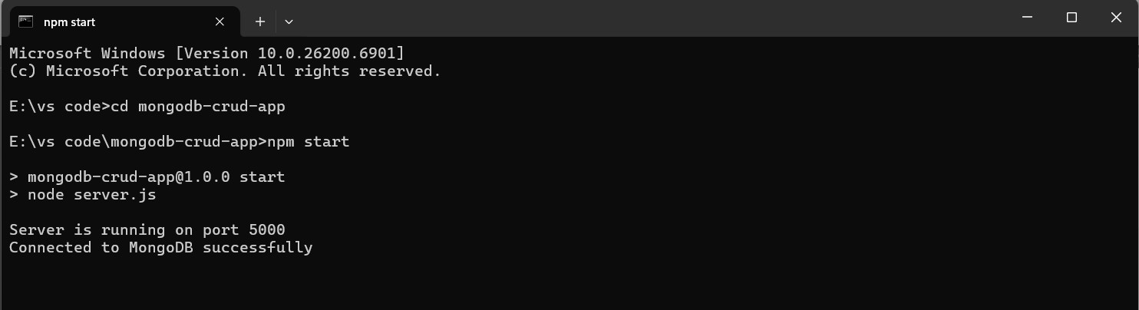

Frontend:
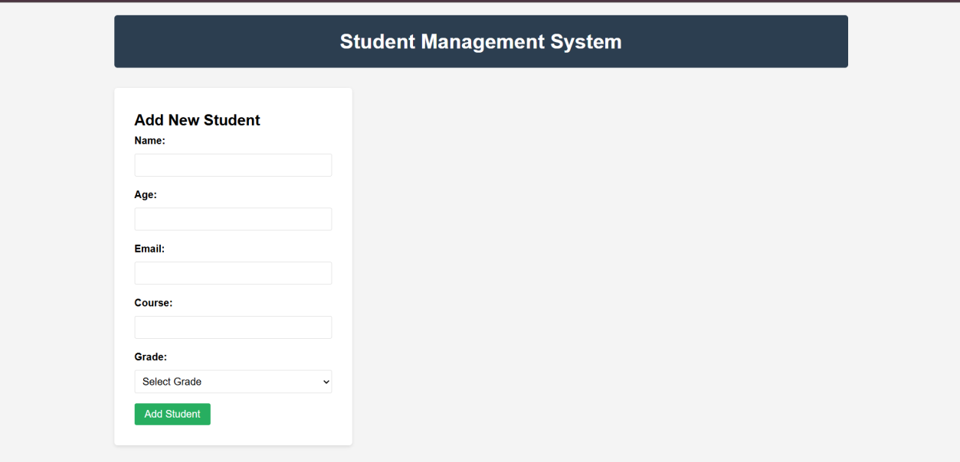
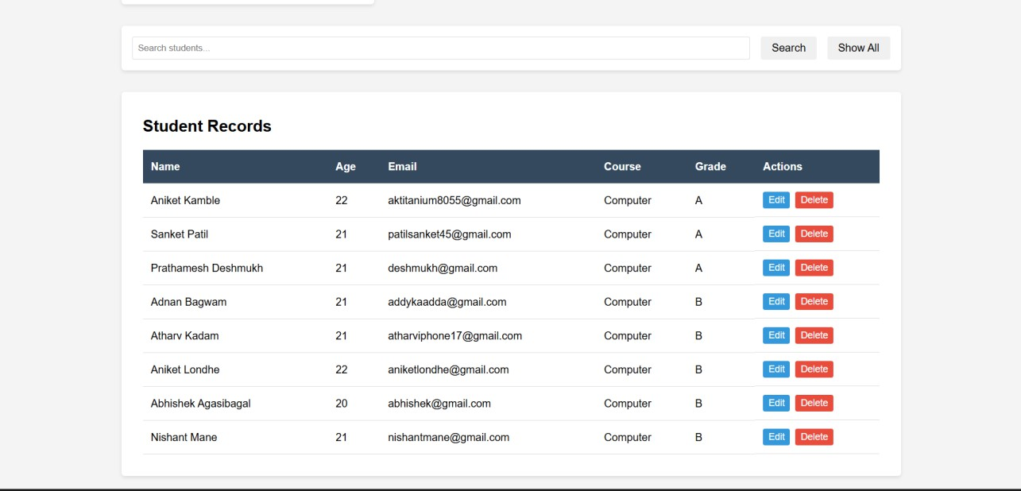

Edit/update info:
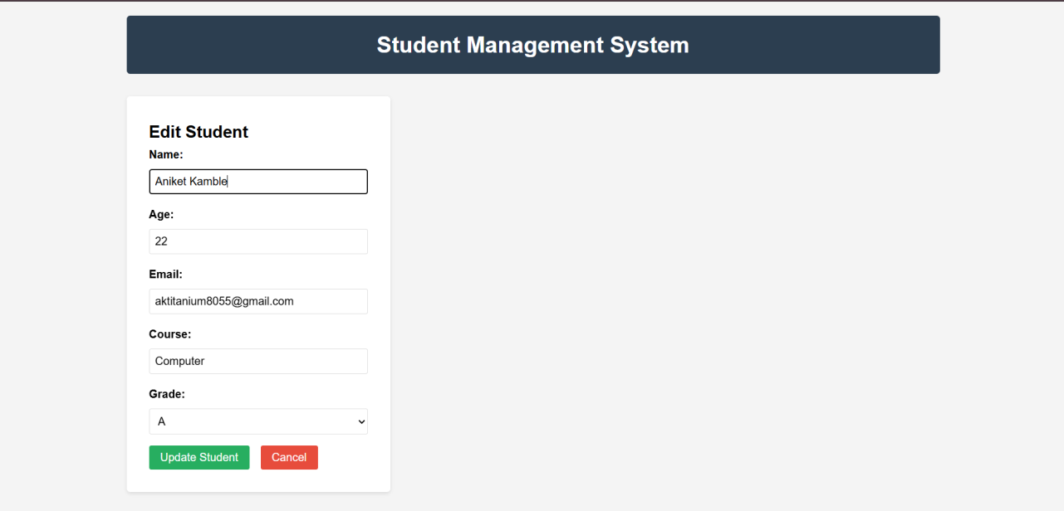

Search:
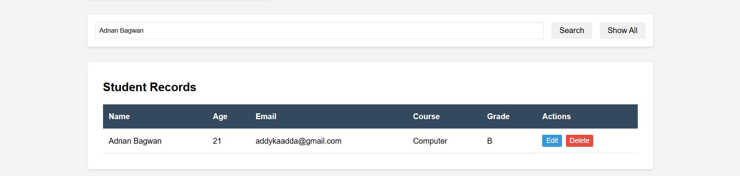

Show all:

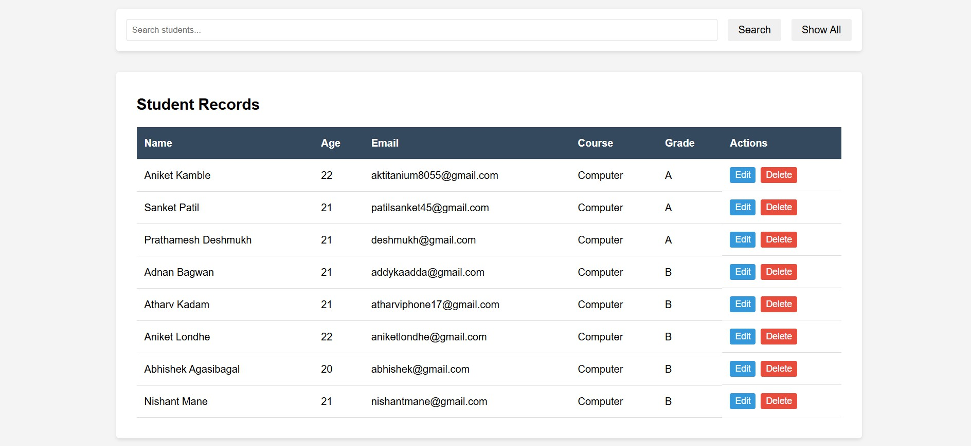

Delete record:
